**1Password SCIM Bridge EKS Deployment & Transition Documentation**

1. **Introduction**

This documentation outlines the full deployment process, configuration details, and transition plan for managing the 1Password SCIM bridge on an AWS EKS cluster using Fargate. It is intended for the Cloud Operations team to take ownership of ongoing support and upgrades.

1. **Prerequisites & Scope**

**Scope**

Transition the management of the 1Password SCIM bridge deployed on EKS to the Cloud Operations team.

**Prerequisites**

* AWS CLI and eksctl configured
* Access to AWS Console and IAM roles
* Kubernetes CLI ( kubectl ) configured
* Helm installed
* Access to GitHub: <https://github.com/1Password/scim-examples>
* Access to 1Password admin account for SCIM provisioning

1. **Current Setup Overview**

**3.1 Infrastucture**

* AWS EKS cluster (created via ClusterBuild.yaml)
* Fargate profiles: coredns , ingresscontroller , bridge , redis
* OIDC provider associated for IAM roles

**3.2 Application Componets**

* SCIM Bridge deployment ( op-scim-bridge )
* Redis (optional internal service)
* AWS Load Balancer Controller for ingress

**3.3 Configuration Files**

* op-scim-deployment.yaml: SCIM bridge deployment
* op-scim-config.yaml : Environment variables and config
* redis-deployment.yaml , redis-service.yaml : Redis backend
* ingress.yaml : Exposes SCIM bridge via ALB

1. **Step-by-Step Deployment**

**Step 1: Create EKS Cluster**

* Update ClusterBuild.yaml :
  + ClusterName
  + ClusterRole
  + FargateRole
  + Version
  + VPCID
  + Subnets
* Create the Cluster:

# aws cloudformation create-stack --stack-name eks-1password-cluster --template-body file://ClusterBuild.yaml --capabilities CAPABILITY_NAMED_IAM

**Step 2: Create Namespaces**

# Kubectl create namespace dev

# Kubectl create namespace prod

**Step 3: Create Fargate Profiles**

# eksctl create fargateprofile --cluster 1password --name bridge --namespace dev --labels app=op-scim-bridge

# eksctl create fargateprofile --cluster 1password --name redis --namespace dev --labels app=op-scim-redis

**Step 4: Configure CoreDNS**

# kubectl patch deployment coredns -n kube-system --type json -p='[{"op": "remove", "path": "/spec/template/metadata/annotations/eks.amazonaws.com~1compute-type"}]'

# kubectl rollout restart -n kube-system deployment coredns

**Step 5: Setup AWS Load Balancer Controller**

# curl -O <https://raw.githubusercontent.com/kubernetes-sigs/aws-load-balancer-controller/v2.4.4/docs/install/iam_policy.json>

# aws iam create-policy --policy-name AWSLoadBalancerControllerIAMPolicyv2 --policy-document <file://iam_policy.json>

# eksctl create iamserviceaccount --cluster=1password --namespace=kube-system --name=aws-load-balancer-controller --role-name AmazonEKSLoadBalancerControllerRole --attach-policy-arn=arn:aws:iam::ACCOUNT_ID:policy/AWSLoadBalancerControllerIAMPolicyv2 –approve

# helm repo add eks https://aws.github.io/eks-charts

# helm repo update

# helm install aws-load-balancer-controller eks/aws-load-balancer-controller \

-n kube-system \

--set clusterName=1password \

--set serviceAccount.create=false \

--set serviceAccount.name=aws-load-balancer-controller \

--set image.repository=602401143452.dkr.ecr.us-east-1.amazonaws.com/amazon/aws-load-balancer-controller \

--set region=us-east-1 \

--set vpcId=vpc-xxxxxxxx

**Step 6: OIDC Association**

# eksctl utils associate-iam-oidc-provider --cluster 1password –approve

**Step 7: Create SCIM Session Secret**

# kubectl create secret -n dev generic scimsession --from-file=./scimsession

1. **SCIM Bridge Deployment**

**Step 1: Configure** op-scim-config.yaml

* Set OP_LETSENCRYPT_DOMAIN to your SCIM domain
* Optionally configure:
  + OP_REDIS_URL , OP_PRETTY_LOGS , OP_DEBUG

**Step 2: Apply the Depoyment**

# cd scim-examples/kubernetes

# kubectl apply -f .

**Step 3: Configure DNS**

# kubectl describe ingress op-scim-bridge -n dev

Use the LoadBalancer IP for DNS record creation.

**Step 4: Validate Deployment**

# curl --header "Authorization: Bearer <token>" https://<domain>/scim/Users

1. **Upgrade Procedures**

# kubectl set image deploy/op-scim-bridge op-scim-bridge=1password/scim:v2.9.9

# kubectl get pod <pod_name> -n prod -o jsonpath='{.spec.containers[0].image}'

* Manually update op-scim-deployment.yaml for consistency

1. **Rollback & Troubleshooting**

* Re-deploy older versions form GitHub repo
* Use OP_DEBUG for verbose logs
* Remove faulty configmap and restart:

# kubectl delete configmaps op-scim-configmap

# kubectl apply -f .

# kubectl scale deploy op-scim-bridge --replicas=0 && sleep 3 && kubectl scale deploy op-scim-bridge --replicas=1

1. **Monitoring & Alerts**

* Moogsoft integrated for alerting on pod failures, memory issues, readiness probe
* Alerts route though standard CloudOps escalation paths

1. **Access & Permissions**

* Ensure access to:
* AWS IAM roles
* Kubernetes cluster via kubeconfig
* Secrets: create/delete scimsession
* Moogsoft dashboard for alerts

**10. Diagrams**

* 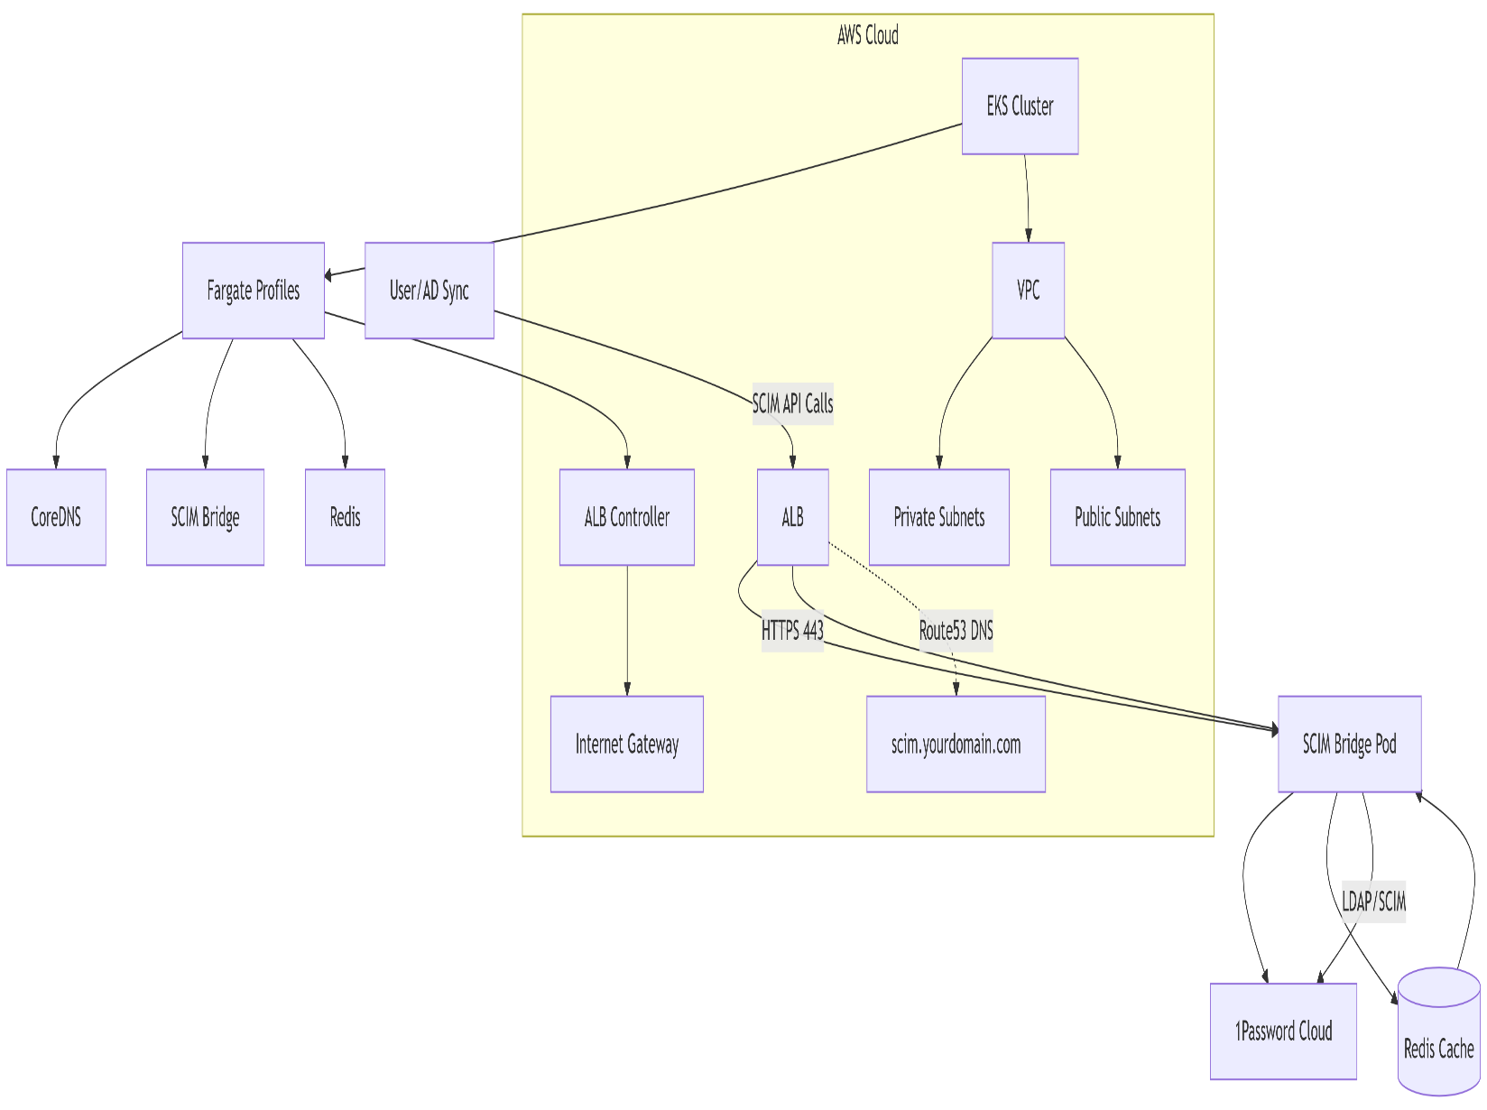Architecture Diagram
* Transition Flow Diagram

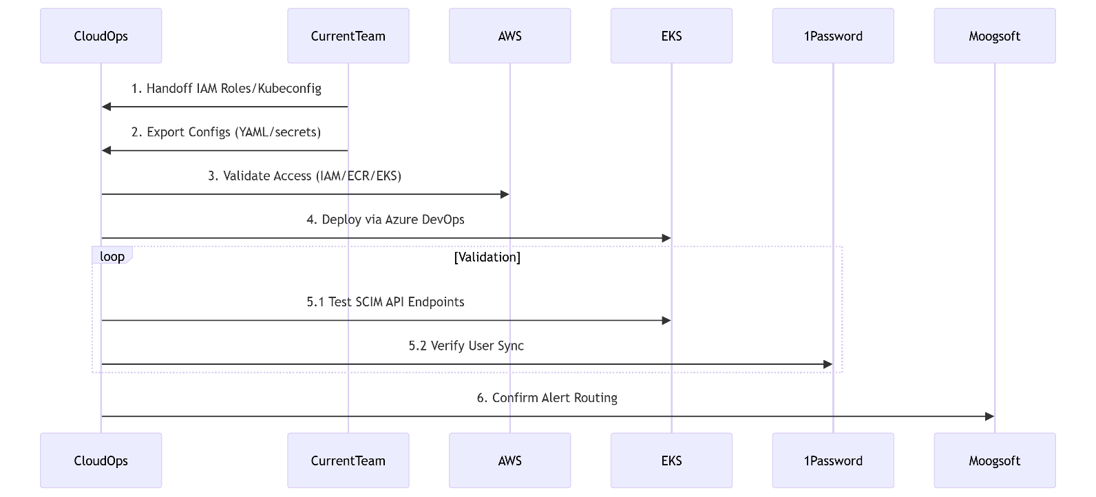

**11. Transition Flow Breakdown**

**1. Provision CloudOps IAM Role Access**

CloudOps must assume the same or a superset of IAM roles as the SCIM bridge and ALB Controller.

**2. Export Existing SCIM Bridge Configs**

Pull op-scim-deployment.yaml , op-scim-config.yaml , and existing secrets from the current cluster.

**3. Deploy to New Cluster via Azure DevOps Pipeline**

Use the existing Azure DevOps Pipeline to deploy to the new cluster.

**4. Validate AD Sync**

Confirm end-to-end provisioning of users and groups using test calls or health check endpoints.

**Appendix**

GitHub Repo: <https://github.com/1Password/scim-examples>

1Password SCIM Docs: <https://support.1password.com/cs/scim/>